**Yoga Class Admission Form – Project**

**Tech Stack : Flask, SQLLite, Python**

Basic Details Required in Form

UserName – Name of the candidate

MailID – email address of the candidate

Password – Password of the candidate

Age – Age of the candidate

MonthToEnrol – Enrolment month

BatchTimings – Chosen timing of Yoga

**Restrictions:**

Age limit – (18 to 65)

Batch Changes – Batch can be changed in different months. That is, a person cannot change batches two times in a single month

Fees Payment – Monthly fees is 500/- . A candidate can enrol in a month and pay fees at any time during the same month. A person cannot pay more than once in the same month, that is, advance payments cannot be made

**Proposed Solution:**

We would be using a person’s username to be his unique identifier. We would be maintaining three tables namely, PERSON, BATCH_DETAILS and PAYMENT for our database schema.

The detailed ER Diagram of the same is as follows:

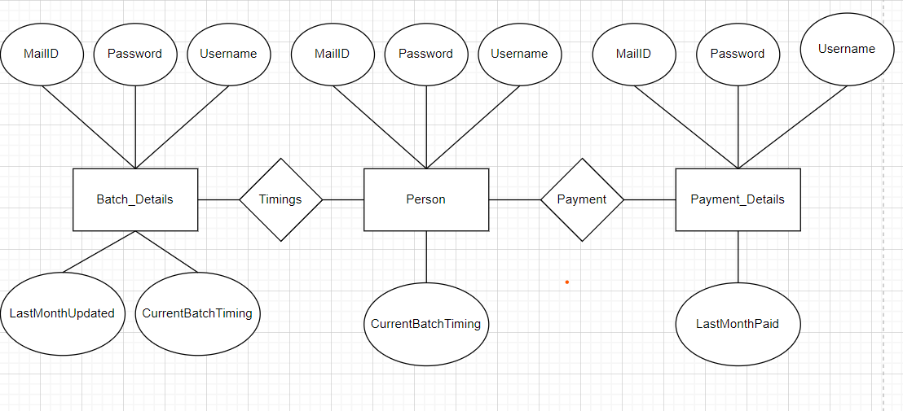

**Logic For Batch Changes and Payment Page:**

**CHANGE_BATCH:**

Attributes : Username, mailID, Password, last_month_changed, current_batch_timing  
Values accepted by form : Username, Password, current_month, new_batch_timing

We keep track of a person’s last month of batch change so that they cannot change twice in same month.

If current_month> lastMonthChanged

* Current_batch_timing = new_batch_timing
* Last_month_changed = current_month

Else

* Can’t change the batch right now! Try again next month.

Assumptions:

1. Batch changes can be done sequentially. That is, if a person has changes his batch in July, he can make changes only between August to December. Trying to make changes to month prior to July is not allowed
2. Trying to change batches for the same timing is not allowed. That is a person trying to change batch from 7-8 AM slot to the same slot is deemed illegal.

**PAYMENT:**

Attributes : Username, password, current_month

Values Accepted : current_month

If current_month> last_paid_month

* Last_paid_month = current_month
* Display payment done. Thank You!

Else

* You’ve already paid for this month.

Assumptions:

1. The first time user enrolls for the Yoga class, they pay the fees at the same time.
2. Fees payment should be done in a linear fashion. That is if the last paid month was January, the next payment month should be February. Paying for months apart from February is deemed illegal payment.

Limitations of The Project:

1. Months are case sensitive and one is expected to type the exact spelling. Since, there is a dictionary being used to convert months to their corresponding numbers, any inconsistency in the name of month would result in an error.
2. The UI of the project could be improved.